**Linux Commands – Beginner to Intermediate Notes**

**1. Basic File System Navigation**

| **Command** | **Description** | **Example** |
| --- | --- | --- |
| pwd | Shows current working directory | pwd |
| ls | Lists files and directories | ls, ls -l, ls -a |
| cd | Changes the directory | cd Documents, cd .. |
| mkdir | Creates a new directory | mkdir new_folder |
| rmdir | Removes an empty directory | rmdir old_folder |
| touch | Creates a new empty file | touch file.txt |
| clear | Clears the terminal screen | clear |

**2. File and Directory Operations**

| **Command** | **Description** | **Example** |
| --- | --- | --- |
| cp | Copies files or directories | cp a.txt b.txt |
| mv | Moves or renames files | mv old.txt new.txt |
| rm | Removes files or directories | rm file.txt, rm -r folder |
| cat | Displays contents of a file | cat file.txt |
| nano | Opens file in text editor | nano notes.txt |
| vim | Advanced text editor | vim script.sh |

**3. File Permissions and Ownership**

| **Command** | **Description** | **Example** |
| --- | --- | --- |
| ls -l | Lists permissions & ownership | ls -l |
| chmod | Changes file permissions | chmod +x script.sh |
| chown | Changes file owner/group | sudo chown user:user file.txt |

**4. System Information & Monitoring**

| **Command** | **Description** | **Example** |
| --- | --- | --- |
| uname -a | Displays system info | uname -a |
| top | Shows real-time processes | top |
| htop | (Enhanced top) | htop |
| df -h | Disk space usage | df -h |
| du -sh | Folder size | du -sh folder/ |
| free -h | Shows memory usage | free -h |
| uptime | System uptime | uptime |

**5. Network Commands**

| **Command** | **Description** | **Example** |
| --- | --- | --- |
| ping | Tests network connectivity | ping google.com |
| ifconfig / ip a | Displays network interfaces | ip a |
| hostname | Shows or sets hostname | hostname |
| curl | Transfers data from or to a server | curl example.com |
| wget | Downloads files from the internet | wget http://example.com/file.zip |

**6. Searching & Filtering**

| **Command** | **Description** | **Example** |
| --- | --- | --- |
| grep | Searches text in files | grep "main" file.cpp |
| find | Finds files/directories | find . -name "*.txt" |
| locate | Finds files quickly | locate notes.txt |
| sort | Sorts lines of a file | sort list.txt |
| uniq | Removes duplicate lines | `sort data.txt |
| head | Shows first N lines | head -n 10 file.txt |
| tail | Shows last N lines | tail -n 5 log.txt |
| cut | Cuts out columns of text | cut -d ":" -f 1 /etc/passwd |

**7. Process Management**

| **Command** | **Description** | **Example** |
| --- | --- | --- |
| ps | Shows active processes | ps aux |
| kill | Kills process by PID | kill 1234 |
| killall | Kills all by name | killall firefox |
| xargs | Executes command on multiple inputs | `cat files.txt |

**8. Archiving & Compression**

| **Command** | **Description** | **Example** |
| --- | --- | --- |
| tar | Archives/compresses files | tar -czvf archive.tar.gz folder/ |
| zip/unzip | Compresses or extracts ZIP files | zip files.zip *.txt, unzip files.zip |

**9. Miscellaneous Useful Commands**

| **Command** | **Description** | **Example** |
| --- | --- | --- |
| history | Shows command history | history |
| sudo | Runs command with superuser rights | sudo apt update |
| echo | Prints message to screen | echo "Linux Notes" |
| date | Shows current date/time | date |
| cal | Displays calendar | cal |
| whoami | Shows current user | whoami |

**10. Common Keyboard Shortcuts**

* CTRL + C: Stop current command
* CTRL + D: Exit terminal or end input
* TAB: Auto-complete command/path
* CTRL + L: Clear terminal
* !!: Repeat last command

**Recommended Practice**

* Practice navigation using cd, ls, pwd
* Create and manage files with touch, nano, cp, rm
* Use grep, find, and cut to search/filter data
* Monitor system health using top, free, df

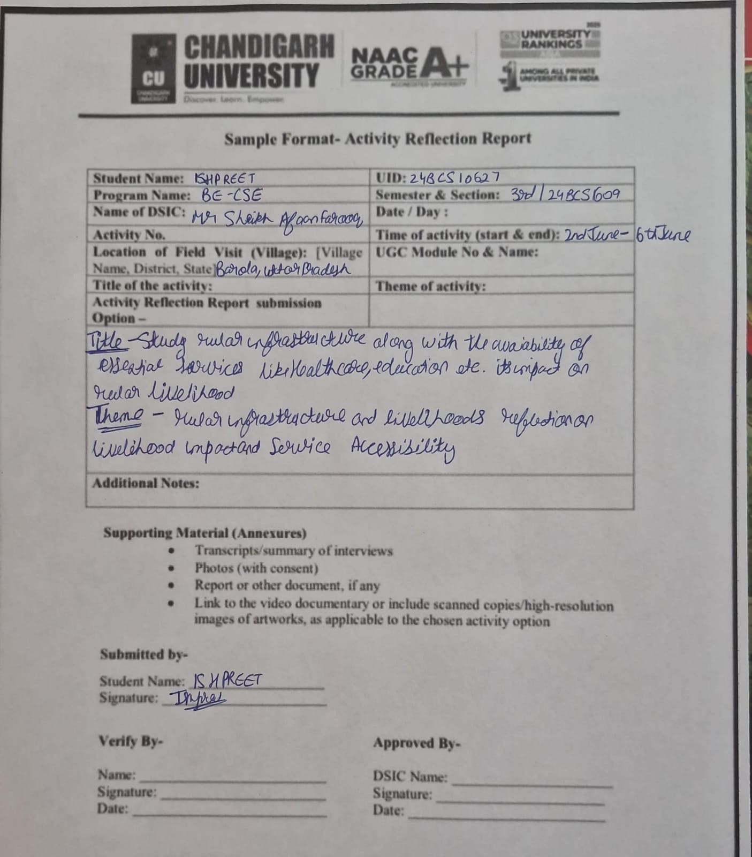

DAY 1

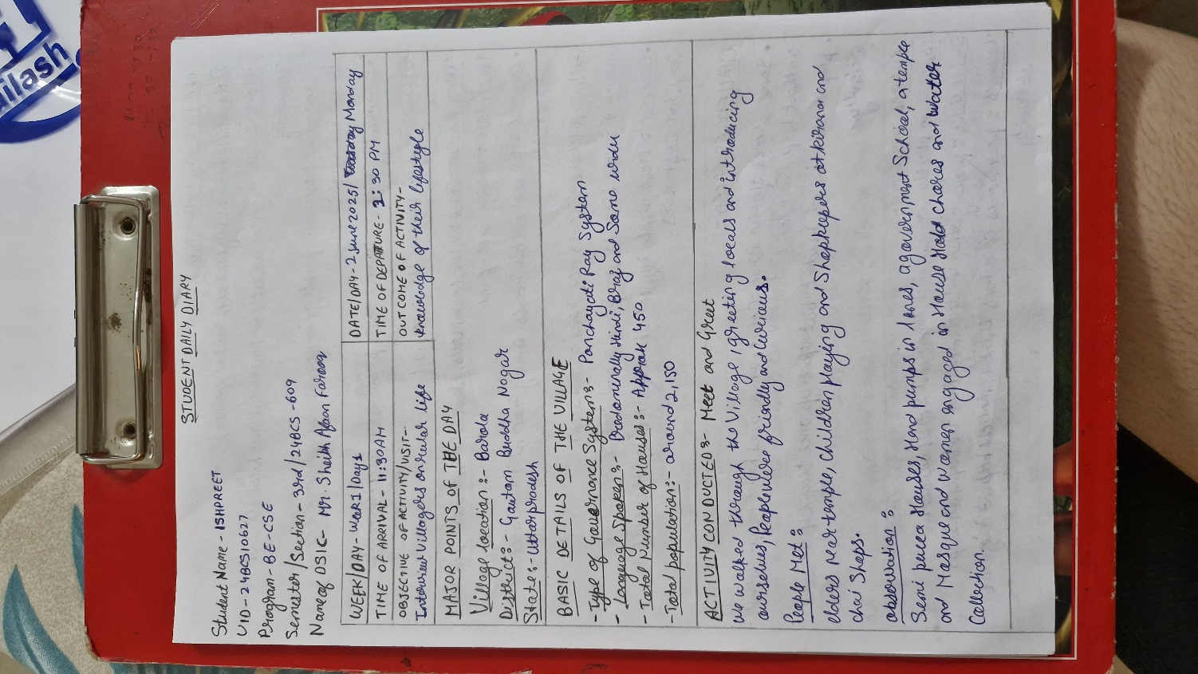  
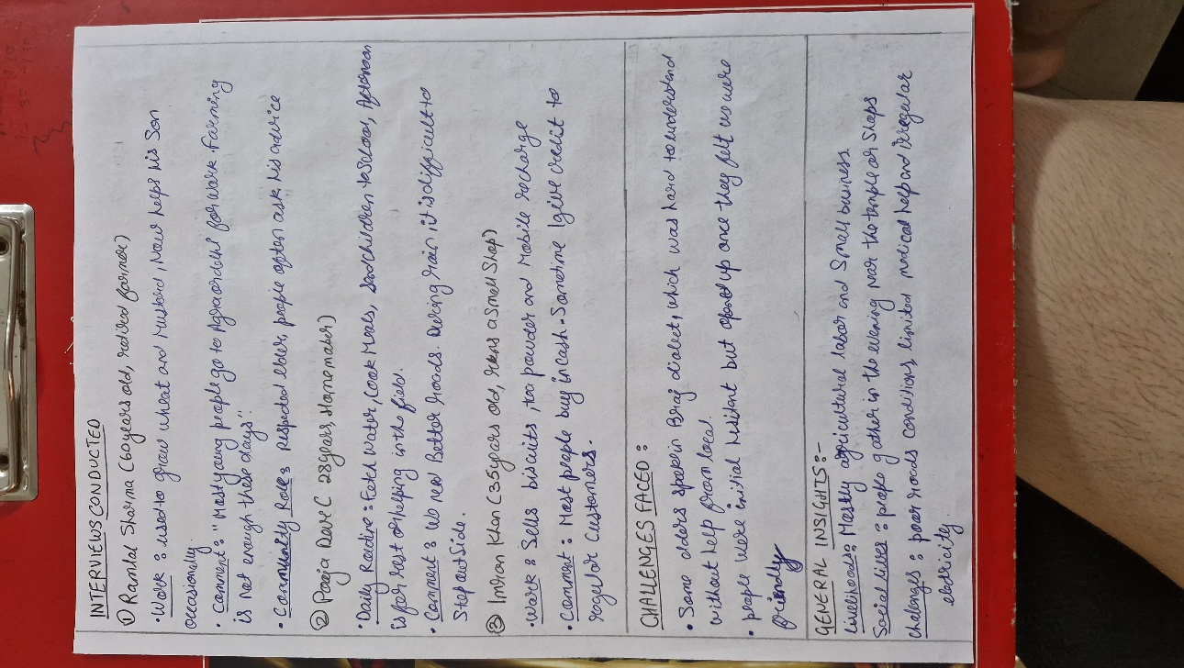  
  
  
  
  
  
  
DAY 2  
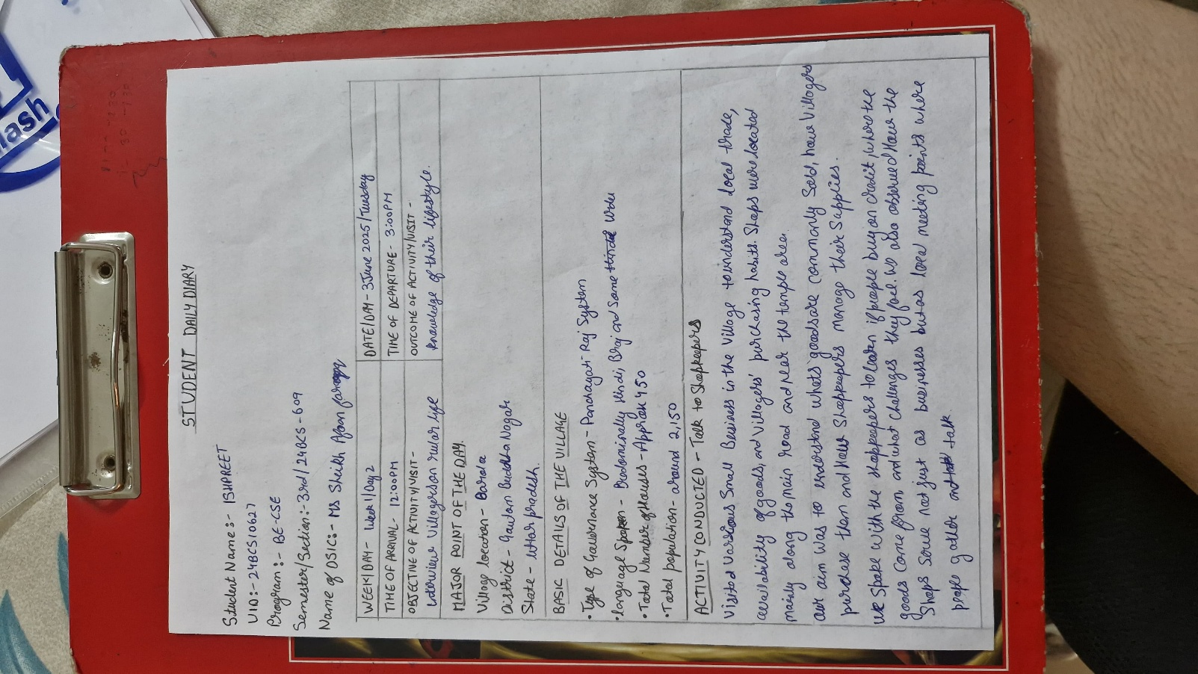  
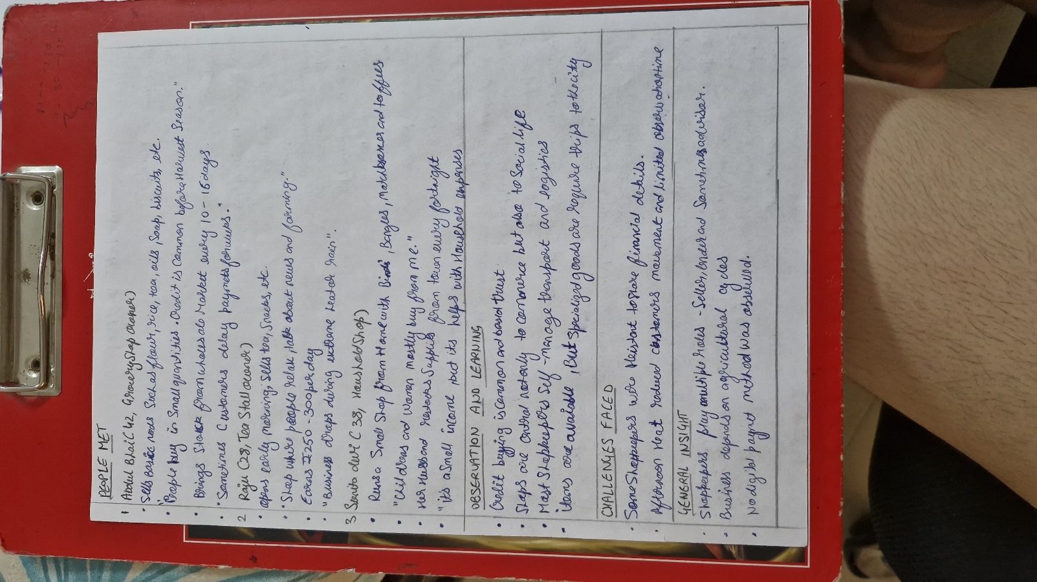

DAY 3  
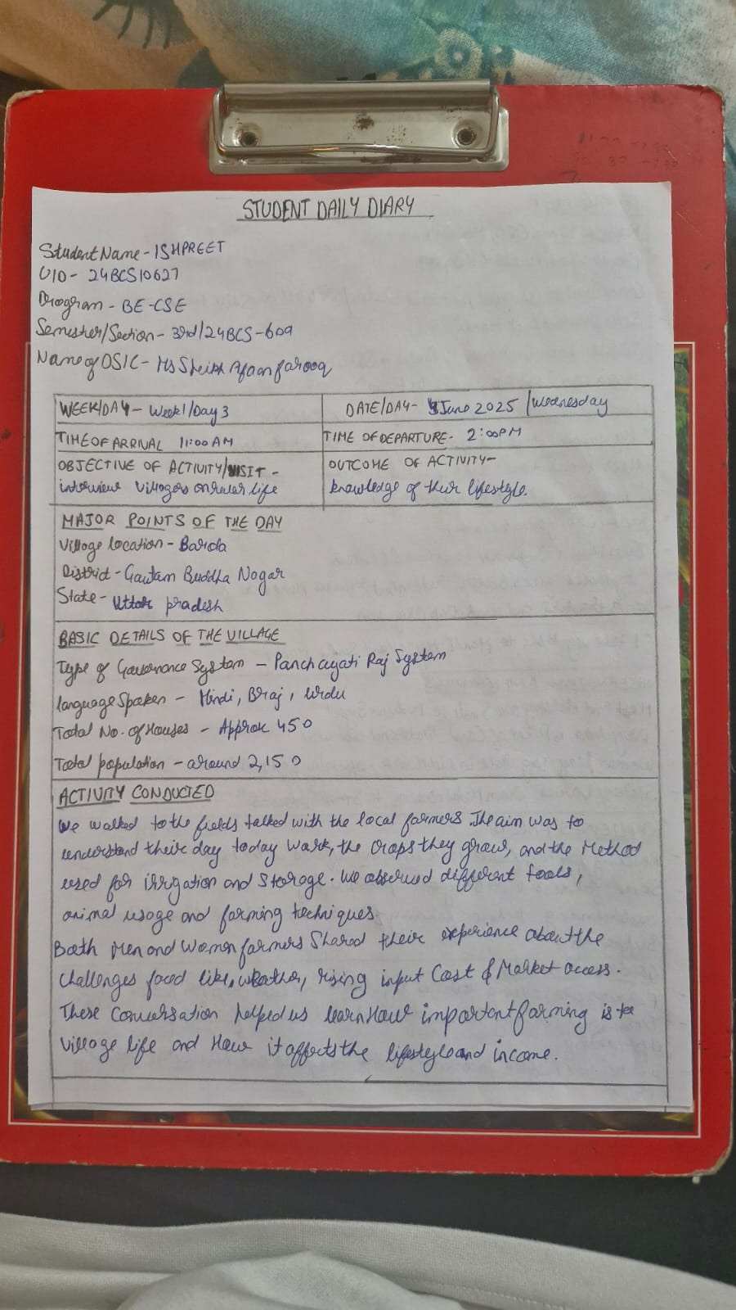  
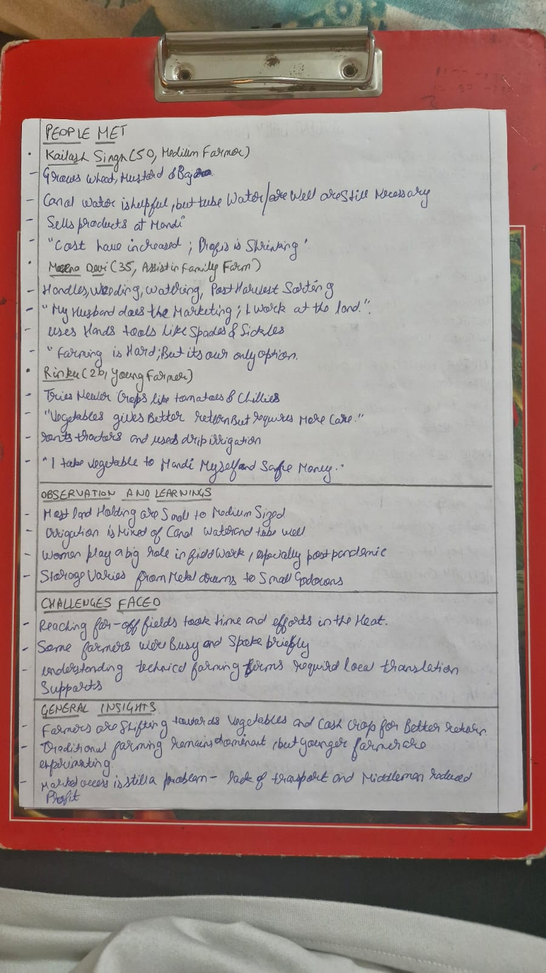  
DAY 4  
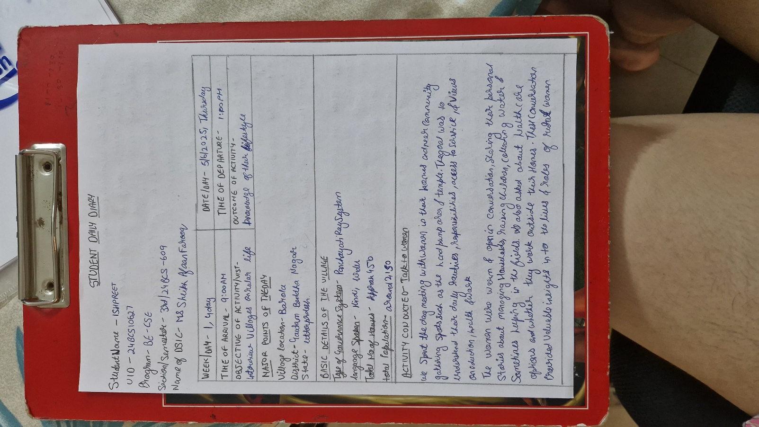  
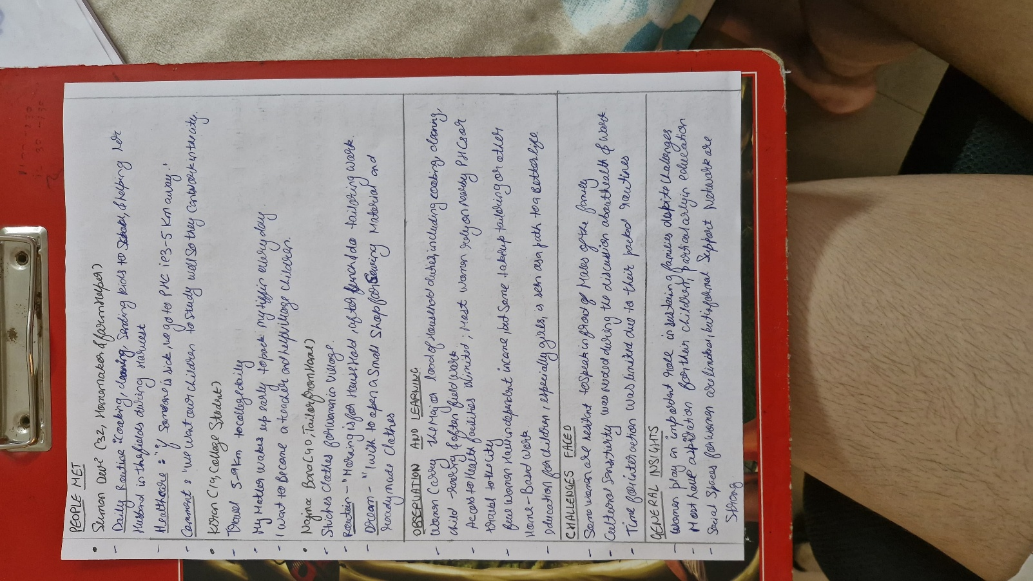  
  
  
  
  
  
  
DAY 5  
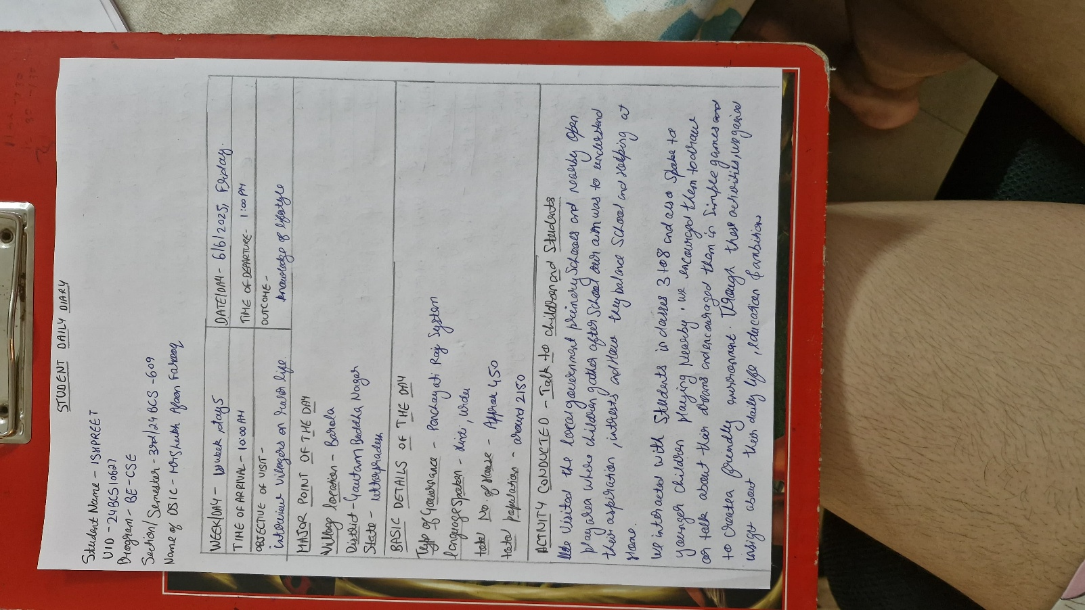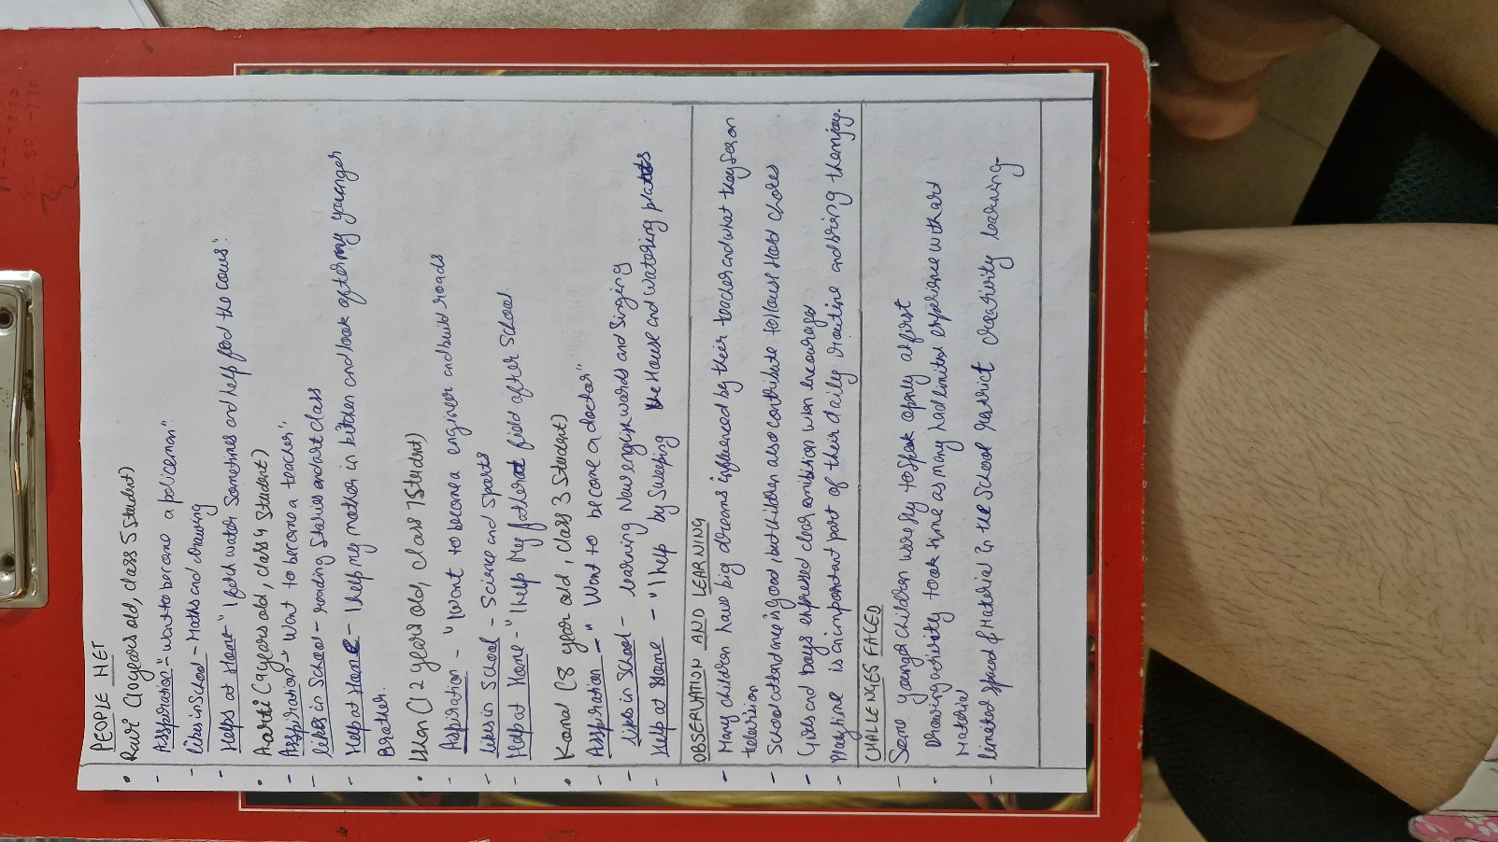  
  
  
PHOTO GALLERY   
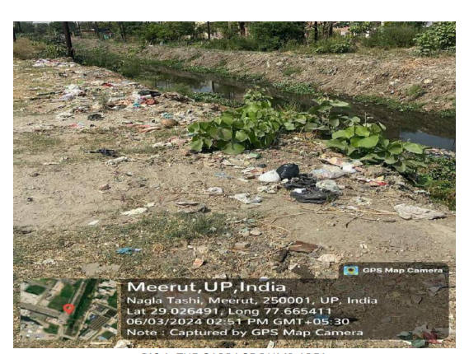  
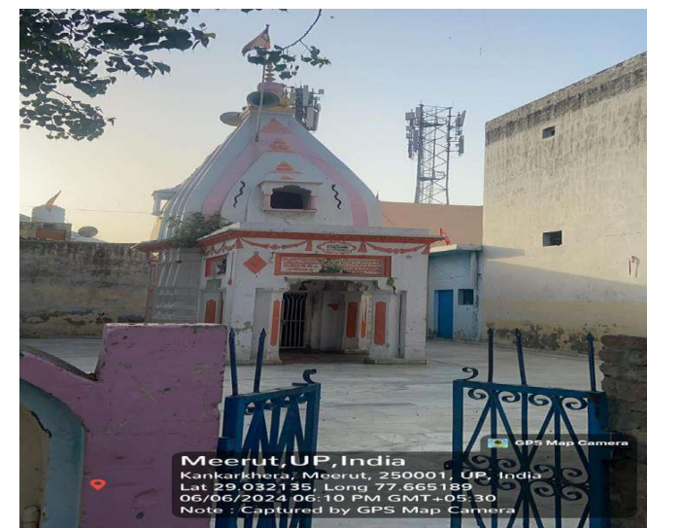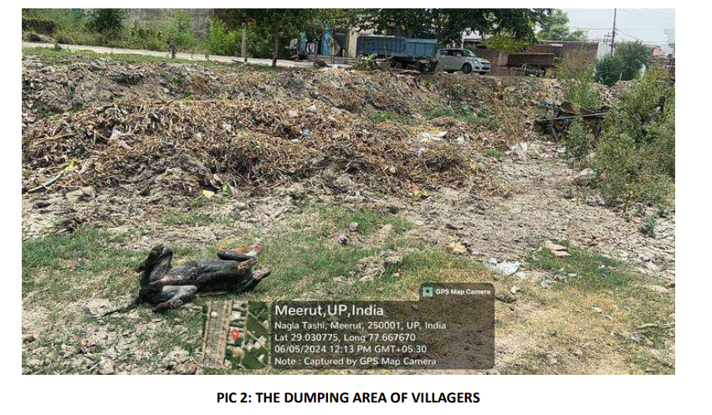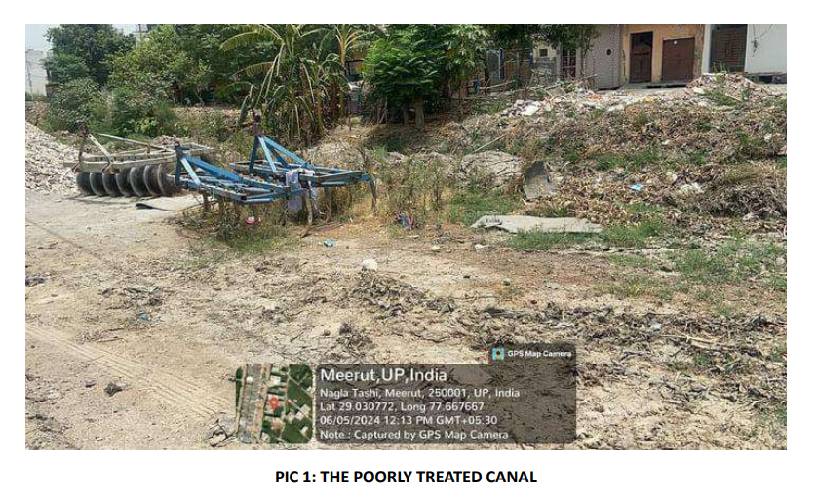  
VIDEO LINK   
  
https://drive.google.com/file/d/1sz5NaSi-K8z-VhB2t8SVA5ScW4OSZHeW/view?usp=sharing